Cellar Ontology load procedure

Date: | 14.08.2013
Version: | 1.0
Authors: | Fulgencio Sanmartín
Revised by:

Document History

Version | Date | Comment
0.001 | 19.11.2012 | Document creation
0.002 | 23.11.2012 | Stopping ingestions
0.3 | 08.08.2013 | Infrastructures: added questions
1.0 | 14.08.2013 | Rewrite a formal version, separating NAL/Eurovoc and Onto.

1. Get ontology svn delivery version

The corresponding DMT/DMP must specify the version of the ontology to be installed. The ontology is checked in and maintained by the Cellar team, who will specify every version delivery as either
- svn number,
- CDM release,
- or most probably, both.

The svn is located at the moment of writing this document in:
http://opsrv230:8080/publications/svn/MetaConv/trunk/cdm/

In the svn log we could see:
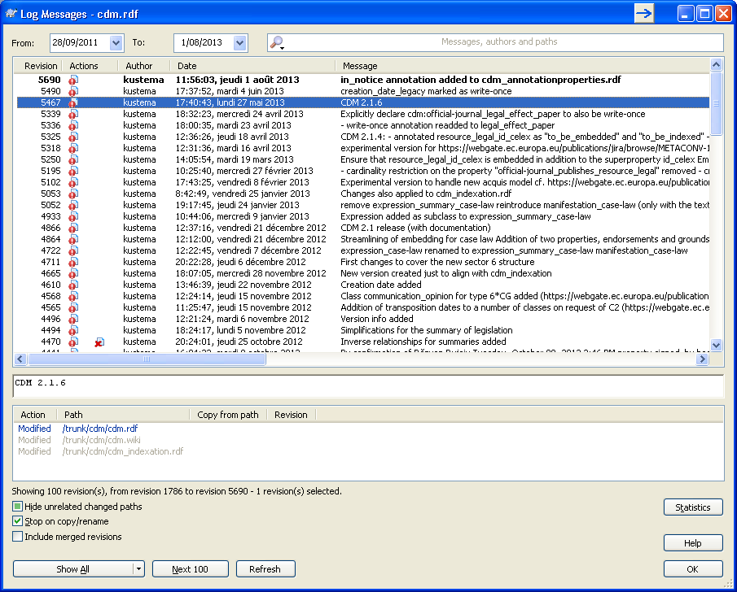

So we should get the files for the version stated in the Revision column, or the Message column: for example, svn 5467 and CDM 2.1.6 would be the same version.

In order to check the log or get files from the svn please refer to its manual.

A delivery of a specific ontology version consists of 6 files:
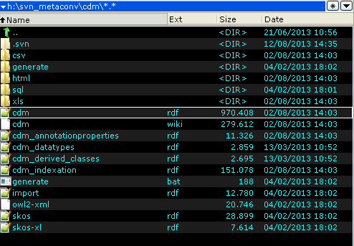
- cdm.rdf
- cdm_annotationproperties.rdf
- cdm_datatypes.rdf
- cdm_derived_classes.rdf
- cdm_indexation
- import.rdf

Download to a local folder all 6 files corresponding to the svn version specified in the DMT/DMP.

2. Load ontology to Cellar administration interface
In the DMT/DMP, the Cellar to be used will be specified. In the following pictures Cellar2-dz will be used as an example.

2.1. Open Cellar admin interface and go to the Ontology tab. Take note of the Ontology version used [CDM & active=YES]:
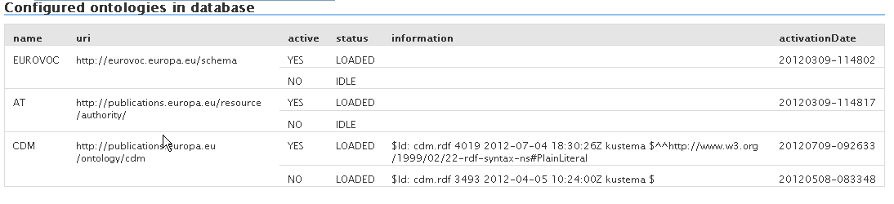
2.2. In the dropdown box, select http://publications.europa.eu/ontology/cdm (cdm):
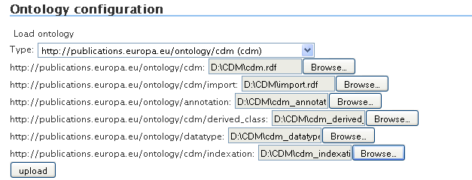

2.3. For each Browse button, take the corresponding rdf file that was previously downloaded from the svn. When all 6 are specified, click the upload button.

3. Check everything went well
Usually in a few minutes, when reloading the onto admin page, there should be a new version loaded and active like this:
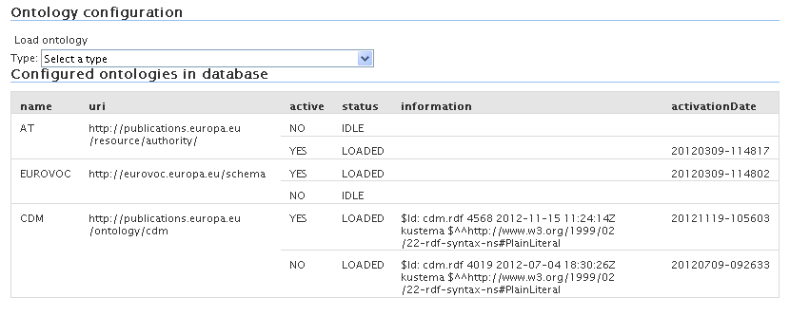
If there were any errors, they will be shown in the jboss log, the report looks like:

2013-07-05 11:51:20,170 INFO [CMR_NAL_LOAD] (RE)LOAD PROCESS ONTOLOGY 'http://publications.europa.eu/ontology/cdm' FINISHED in 35 sec.
2013-07-05 11:51:20,171 INFO [CMR_NAL_LOAD] #### ONTOLOGY LOAD REPORT ####
2013-07-05 11:51:20,171 INFO [CMR_NAL_LOAD] LOAD ONTOLOGY 'http://publications.europa.eu/ontology/cdm' SUCCESSFUL:
2013-07-05 11:51:20,171 INFO [CMR_NAL_LOAD] - new operational ora onto model: 'CDM_ONTOLOGY'
2013-07-05 11:51:20,171 INFO [CMR_NAL_LOAD] RECONFIGURATION SUCCESSFUL
2013-07-05 11:51:20,172 INFO [CMR_NAL_LOAD] #### END ONTOLOGY LOAD REPORT ####

